

WA Desktop Connector

User Guide
Version 1.0.0
Professional Desktop Integration for Odoo Documents
Developed by
Wim Audenaert
Odoo Expert & Consultant
August 2026
Copyright © 2026 Wim Audenaert

1. Introduction
WA Desktop Connector allows users to open documents stored in Odoo Documents directly in their native Windows desktop applications. After editing and saving the file, the updated version is synchronized back to Odoo.

2. First-time installation
The Windows Connector only needs to be installed once on each workstation.
1. Download 'WA Desktop Connector Setup.exe' from Odoo.
2. Run the installer.
3. Accept the Windows security prompts if they appear.
4. After installation, the connector is ready for use.

3. Opening a document from Documents
Click the document in the Documents application. A choice dialog is displayed allowing you to open the document in the Windows desktop application or, when supported, in Odoo.
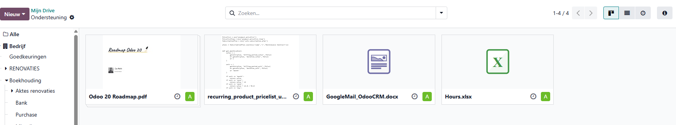
Documents application
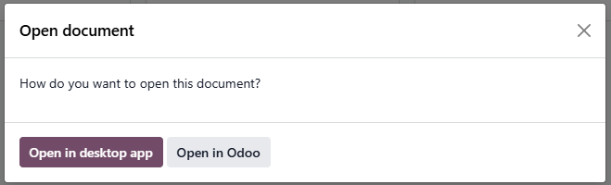
Open document dialog
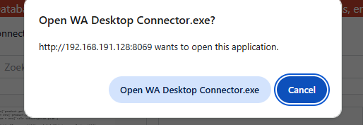
Browser confirmation

4. Opening a document from Actions
Alternatively, select a single document in the Documents list and choose Actions → Open on Desktop.
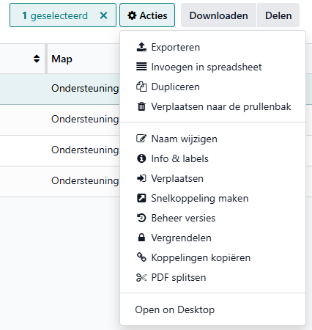
Actions → Open on Desktop

5. Saving changes
Edit the document as usual in the desktop application and save it normally. WA Desktop Connector automatically synchronizes the updated document with Odoo.

6. Frequently Asked Questions
Why does my browser ask for confirmation?
This is a normal browser security feature before launching a local application.
Can I continue to use Odoo Spreadsheet?
Yes. Choose 'Open in Odoo' for supported spreadsheet documents.
Do I need to install the connector more than once?
No. Installation is only required once per Windows workstation.

7. Troubleshooting
If the desktop application does not open:
• Verify that WA Desktop Connector is installed.
• Verify that the browser confirmation was accepted.
• Verify that a Windows application is associated with the selected file type.

